St Martins School Primary Phase Summer 1 Term Overview Year 5
ICT Using the Scratch programme, pupils will create animated historical stories that will relate to events during the Viking period in Britain.
R.E.
How do Sikhs mark special times in their life?

Art Topic
Viking shield designs printing Viking letters onto the shields in preparation for role play.

P.E. Rounders and keep fit.

Music Composition – Penny Whistles

PSHE Changes and sex education. The children will learn about the physical and emotional changes during puberty. They will also learn about how babies are created.
Literacy Writing balanced arguments derived from debates about the Viking influence on Britain. Drama and role play connected to the Viking topic. Informal letter writing and how they differ from formal letters. Grammar and punctuation will focus on identifying phrases, tenses, expanded noun phrases, brackets and dashes, imaginative vocabulary, synonyms and antonyms, main and subordinate clauses and modal verbs. The reading focus for the term will be using inference and deduction skills to learn about the past from ancient texts. For example what the Anglo-Saxon chronical tells us about the Vikings and their relationship with Britain.

History Topic This topic focuses on the Vikings and who they were, where they came from and why did they come to Britain. The children will investigate Viking raids and warfare, as well as home life and the role of women and children. They will consider how historians know about the Vikings, and examine both archaeological and written sources in order to draw their own conclusions.
Mathematics Recognise the per cent symbol (%) and understand that per cent relates to ‘number of parts per hundred’, and write percentages as a fraction with denominator 100, and as a decimal. Solve problems which require knowing percentage and decimal equivalents of 1⁄2, 1⁄4, 1⁄5, 2⁄5, 4⁄5 and those fractions with a denominator of a multiple of 10 or 25. Identify 3-D shapes, including cubes and other cuboids, from 2-D representations. Know angles are measured in degrees: estimate and compare acute, obtuse and reflex angles. Draw given angles, and measure them in degrees (0) Identify: angles at a point and one whole turn (total 360); angles at a point on a straight line and 1/2 a turn (total 180); other multiples of 90. Use the properties of rectangles to deduce related facts and find missing lengths and angles. Distinguish between regular and irregular polygons based on reasoning about equal sides and angles.

Science topic Animals including humans: diet and lifestyle. The children will learn about the impact of diet, exercise, drugs and lifestyle on the ways their bodies function. They will identify the main parts of the human circulatory system, and describe the functions of the heart, blood vessels and blood.
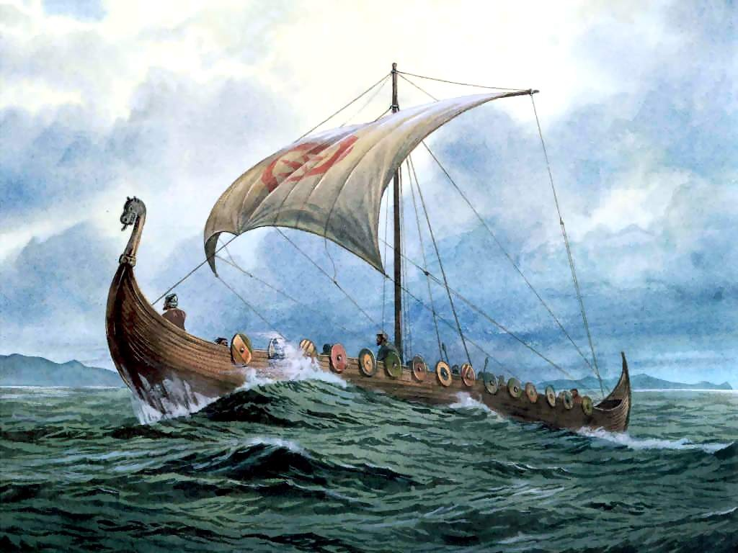
The Vikings
SUMMER TERM 2019
Theme Rationale Pupils will explore part of the narrative of the history of Britain and how the Vikings shaped what Britain is today. The topic will link with other areas of the curriculum where possible, including drama and literacy.

