Dear parent/carer of year 8 and 9
RE: Options
At St Martins School we deliver a broad and balanced curriculum which is guided by the national curriculum. It prepares our students for continuing learning and study post 16 and also provides them with knowledge, skills and understanding to prepare them to play a full and active part in society.

Although this is a difficult time for us all, we are planning our curriculum and teaching groups for September. There are now some ‘options choices’ that many of our students need to take.

Year 8
At St Martins School we study ‘arts’ for all. We passionately believe that creativity and adaptability are two keys characteristics that employers of the future will be looking for. Our Arts courses develop our student’s confidence and resilience. Students will need to decide which art subject is their preference for year 9-11.

Year 9
In year 10 all students will continue to study the ‘core subjects’. Art subjects were chosen at the end of year 8 and modern foreign language was selected at the end of year 7.
Additionally, students will study either Public Services Btec or History GCSE, this will be guided by the Head of Humanities and will be confirmed in a letter. Students will need to choose their final choice of subject. The students were sent home with a booklet and form before we closed.
Year 8 | One choice from:  Art GCSE  Performing Arts Btec - drama  Performing Arts Btec – dance  Music Btec  Creative Imedia
Year 9 | One choice from:  Geography GCSE  Food Preparation and Nutrition GCSE  PE GCSE  Media Studies GCSE

All the information and the forms are on the school website - http://www.stmartins3-16.org/students/ks4-and-arts-options/ .Students will need to complete and return their preference form by Monday 4 MAY, or send an email confirming their preference to reception@stmartins3-16.org

Should you have any queries please email school and we will forward to the relevant member of staff. We hope to confirm options later in the summer term.

Thank you for your continued support.

Yours faithfully,
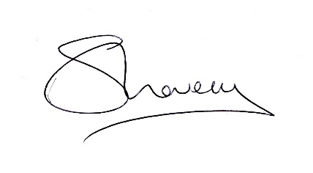
Sue Lovecy
Head of School

