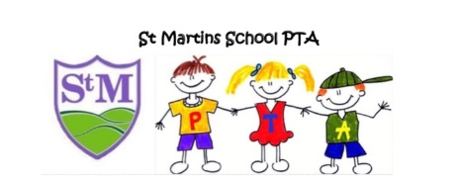

St Martins School PTA
St Martins School
Moors Bank
St Martins
SY10 7BD
Email: pta_stmartins@outlook.com
September 2020
Dear parent / carer,
The PTA welcome you all back to very different school year. We have yet to hold our AGM, should you be interested in joining the PTA please email us or send a direct message via our Facebook group. The current PTA are willing to stand again this year but it would be lovely to have some new faces join us. Normally our meetings are once a month but obviously this year will be less frequent and via Zoom or Microsoft teams.
As you are aware the majority of our fundraising events involve mass gatherings, so as a committee we decided at the end of last year that we would not be holding any fundraising events that include mass gatherings. We also understand the financial strain the pandemic may have caused for some families. The only fundraiser we are looking at organising so far is the design a Christmas Card event (details to follow)
Your continued support of the PTA is very much appreciated and we can’t thank you enough. Any further updates will be posted on the PTA Facebook page and the school website.
Heather Jones
Chair

