St Martins School
3-16 Learning Community

Thank you for the interest you have shown in our school. St Martins School is a very special place to work. We deliver child-centered, individually tailored education because of our small size and unique position in our community. This family ethos surrounds all who work and study here, creating a safe, supportive and nurturing environment. This is an exciting time in the development of our school and I hope you will agree that this role will present you with real challenges and opportunities. I very much hope that, after reading the information below you will feel that you want to play your part in our process of rapid improvement and innovation, securing progress and achievement for all our students.

The Context
REPORT CARD
» Headteacher: Sue Lovecy
» Age 3-16 through school
» Location: Rural Shropshire
» 540 students including nursery
» 32 teachers and 14 teaching assistants
» Became an Academy with The Priory School Trust in September 2016
» Rapidly becoming the school of choice in the local area

North West Shropshire is a rural area with a mining heritage. It is located on the Welsh border with easy access to the Welsh hills. Many staff live in the surrounding countryside while others take advantage of the fact that historic urban areas such as Shrewsbury and Chester are in comfortable commuting distance. Oswestry, a thriving market town, is five miles from the school. The area offers a wide variety of attractive housing at prices which compare favourably with other parts of the country.

The School

St Martins School has undergone a transformation over the past five yearsar. New new leadership, new buildings and facilities, new ‘through school’ and now our new academy status with the Priory School Trust. We work in collaboration with two of the most successful schools in the country. Firstly, The Priory School, our academy partner, and we also continue to work with Moreton Hall School, the leading non- selective school in the country. We are delivering a community curriculum across all our feeder schools, which supports KS2 teaching with exciting projects taught by secondary subject specialists. This work is in addition to the ‘cross phase’ teaching that already takes place within our school, which enables:
- Sharing examples of good pedagogy between phases
- Enhancing continuity between the phases
- Developing an all through school ethos

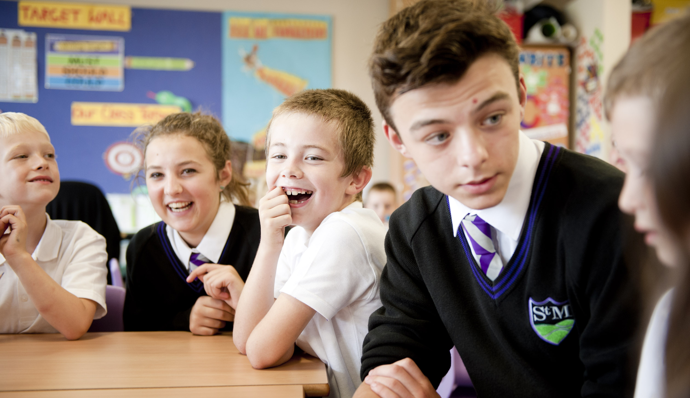
Our mission as part of the Priory School Trust.
We build an education for our students such that they are:
• selfless
• self-assured
• successful

The following ethos is a commitment shared by staff and governors. We will:

• Recognise and foster academic ability so that individual excellence can be achieved.

• Deliver the highest quality teaching, enabling children to maximise their potential throughout their learning journey 3-16

• Create a family ethos of safety, support and nurture where respect for each other is a given

• Create an inclusive environment where children of all abilities and backgrounds make a positive contribution to school life and the wider community

• We will encourage children to think independently and make informed decisions enabling them to have high aspirations about their future
• We will work with children and families in constantly reviewing progress and supporting differing developmental needs
St Martins School can offer you:
» Excellent resources and facilities
» An enthusiastic and supportive team of staff, parents and governors
» Students that strive to be successful, self assured and selfless
» An excellent opportunity to develop your career across a successful MAT
This is an incredibly exciting time as we further develop and maximise the value of being an all through school through the development of the three phases across the school to create synergy, whilst continue to be at the centre of our community and deliver our Community Curriculum with a feeder primary schools

Cleaning Assistant at St Martins School

The cleaning assistant will be responsible for maintaining high standards of hygiene and cleanliness throughout the school.

- To clean areas of St Martins School as directed by the Line manager and in accordance with agreed procedures and rotas.
- To clean and set up rooms and areas as required.
- To provide additional cleaning as necessary after major/additional events to ensure that the building is prepared to the required standard for operational purposes.
- Contributing to the health and safety of children

The role also includes:
- Reporting maintenance faults or issues to the Premises Department
- Ensuring that all rubbish is disposed of correctly once collected
- To operate in accordance with all Health and Safety legislation, and COSHH requirements

As a school we seek:
- An enthusiastic and committed individual, able to motivate and inspire young people
- An individual with a ‘can do’ approach willing to make a significant contribution to the life of the school

“An excellent school with hard working staff who all have my children’s best interest at heart. They develop their emotional and social development as well as their academia”
parent

Person Specification


A detailed person specification is enclosed. It is the criteria set out in this document that will form the basis of our short listing and appointment. They are designed to help you decide whether you could be the person we are looking for. This person will be an individual who is fully committed to working with our students and our staff team to help create a genuinely inclusive school in which the focus is on maximising achievement for everyone.

D.B.S. – Disclosure Process

This post is exempt from the Rehabilitation of Offenders Act 1974 and as such all applicants who are appointed to this post will be subject to an Enhanced Disclosure before the appointment is confirmed. This check will include details of cautions, reprimands or warnings, as well as convictions and non-conviction information. Once appointed, the successful applicant(s) may also be required to apply for an Enhanced Disclosure at intervals during the course of their employment whilst in this post. This school is committed to safeguarding and promoting the welfare of children and young people and expects all staff and volunteers to share this commitment. The successful applicant will be subject to an enhanced DBS check.

The Application

In your application you should:
- complete the enclosed application form
- write a letter of application of not more than 1 side of A4 explaining how you would contribute to our all through school

Before or after making your application, you are welcome to contact the school for further information or to arrange a visit. Please telephone 01691 776500 or email reception@stmartins3-16.org

Applications should be returned by end of school (3.30pm) on 16th October 2020

Successful applicants will be contacted via email and will be required to attend an interview.

Thank you for your interest in this post. I look forward to hearing from you.

Sue Lovecy
Head of School

