Curriculum Map Year 3 Class Teacher(s) Miss Devismes/ Mrs Kerr Spring Term (1st Half) 2021 Title: What’s below the surface?

Stunning Starter: Welcome to the Stone Age! | Magnificent Middle: How to be a Caveman/Woman! | Fantastic Finish: A trip to Oswestry Hill Fort
English:Stone Age Boy by Satoshi Kitamura  Snowdragon by Vivien French  Firefall the school for dragons by Sophie Quay-Clark  Outcome Non-chronological report: write about a particular species of dragon  Sentence Form nouns with a range of prefixes  Use present and past tenses correctly and consistently including the progressive form and the present perfect form  Text Build a varied and rich vocabulary  Punctuation Use inverted commas to punctuate direct speech (and to show relationship between two characters)  Spelling: Suffixes – ‘ness’ and ‘ful’, Prefixes – ‘sub’ and ‘tele-‘Apostrophe for contraction. Handwriting. | Maths:  Measurement: Length  Money  Fractions – Comparing and Ordering Fractions  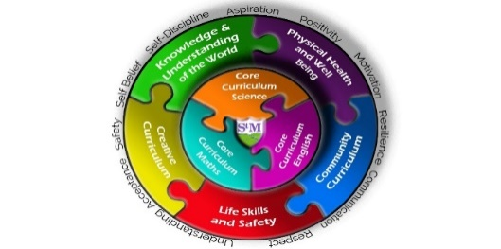  Multiplication and Division | Science  Rocks  Types of Rocks  Grouping Rocks  Fantastic Fossils  Mary Anning  Soil Formation  Soil Profiles
Knowledge & Understanding of the World including British Values  History: Changes in Britain from the Stone Age to the Iron Age – Celts, Skara Brae, Becoming a Copper Child, Stonehenge, The Druids  R.E - What do we know about Jesus?  French |  | Life Skills, Safety & Careers  ICT: I – SAFE  Coding  Safety around the community  Internet Safety
Physical Health & Well-being including outdoor learning  PE – Dance & Gymnastics  PSHE: Going for Goals  Keeping Healthy/ Food and Nutrition  Forest School | Community Curriculum:  Oswestry Hill Fort | Creative Curriculum  ART: Stone Age art – early cave paintings/charcoal. Artist who use charcoal  DT: Cooking and nutrition (Stone Age)  Sculpture – Hill fort.  Music: Three little Birds – Performing and appraising.

