Curriculum Map Year 4/5SS Class Teacher Mr Spelman Spring Term (1st Half) 2021 Title: Escape from Pompeii
Stunning Starter: Horrible History Roman morning |  |  | Magnificent Middle: Roman democracy debate |  |  |  | Fantastic Finish. Designing and making Roman shields.
English Class text: Escape from Pompeii. Class novel: Pompeii: A Roman Girl’s Diary by Sue Reid. Use conjunctions, adverbs and prepositions to express time, place and cause. Create characters, settings and plot in narrative. Group related ideas into paragraphs. Write a sequence of events to follow the structure of a historical story. Variety of verb forms used correctly and consistently including the progressive and the present perfect forms. Use Standard English for verb inflections. Write historical recounts and narratives based on the events in ‘Escape from Pompeii’. Add historical detail to characters, setting and events. Spelling and Handwriting. | Mathematics Number – multiplication and division. Multiply two-digit and three-digit numbers by a one-digit number using formal written layout. Problem solving – multiplication. Multiplying more than two numbers. Problem solving – mixed correspondence problems. Dividing a 2-digit number by a 1-digit number. Measurement. What is area? Counting squares. Making shapes. Comparing area. Number – fractions (including decimals). Adding and subtracting fractions. Problem solving relating to adding and subtracting fractions. What are Tenths? |  |  |  | Science - State of Matter.  Be able to identify if some common substances are solids or liquids. Recognise that air is a gas. Solid, liquid or gas? How do we know? Identify some key features of solids, liquids and gases (e.g. how you can change their shape (Balloon, block, water). Compare and group materials together, according to whether they are solids, liquids or gases. Consider difficult case like toothpaste, sponge, foam. Observe freezing and boiling. Observe that some materials change state when they are heated or cooled, and measure or research the temperature at which this happens in degrees Celsius (°C). Consider the effect adding salt to water on freezing points of water (explain why salt is used on icy days). Water cycle. Know clouds produce rain. Identify the part played by evaporation and condensation in the water cycle (sea, clouds, rain, rivers) and associate the rate of evaporation with temperature. Rain - Link water cycle and temperature to explain why hot countries can have very heavy rain.
Knowledge & Understanding of the World including British Values In Geography children will find out about all the different aspects of the historic country of Italy. They will begin by learning where Italy is in the world, and then discover the physical geography of the country, with a focus on one of Italy’s active volcanoes, Mount Vesuvius! Children will explore the country’s many famous cities and landmarks, and immerse themselves in the culture of Italy. In History, the children will learn about the Roman Empire and its impact on Britain at the time and the legacy it left us. For example, the part democracy played in Roman society and how this is similar to our own system of government.  RE – Who was Jesus? Reflect on their own ideas of how Jesus may have looked. To summarise from evidence what sort of person Jesus was. What did Jesus’ enemies think of him? How did Jesus describe himself? |  |  |  | 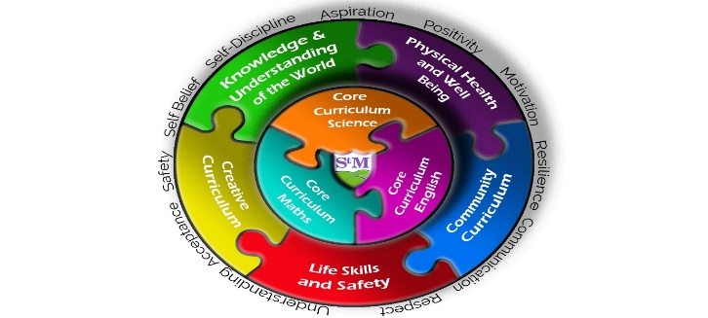 |  | Life Skills, Safety & Careers.  Times tables - Children will be encouraged to learn all their times tables and not only see them as a maths topic but also as a life skill that can be applied to many areas of daily life.  ICT – iWrite - create and test a sequence of statements that make letters of the alphabet. iShape Up - create programs that alter the size of a shape. iRobot - program a robot to draw letters of the alphabet. iDesign - program a robot to pick up a beacon using an if statement or else move in another direction. iFollow - program a virtual  robot to follow markers on a map and retrieve an object.  Safety in the community.
Physical Health & Well -being including outdoor learning  PSHE – Going for Goals. Children will learn the skills and attributes of an effective learner and how to develop these skills. They will learn how to recognise and celebrate our own achievements. PE - Football drills and skills.  Forest School |  | Community Curriculum  A comparison between Italy and our local area. |  |  |  | Creative Curriculum  Art – This term the children will learn all about the Roman Empire. They will design and make a Roman shield in order to assist them in understanding the broader topic. Music-The children will continue their weekly music sessions with Mr James focusing on rhythm, tempo and pitch.

