Curriculum Map Year 4/5 CJo Class Teacher Mrs Jones Spring Autumn 2021(1st half) Title: Norse Adventures
Stunning Starter: Forest School – create a myth based around a tree and the levels of the Norse world. | Magnificent Middle – Creating scenes in drama | Fantastic Finish Make Viking shields
English Arthur and the Golden Rope by Joe Todd-Stanton. Writing outcome: To write a myth with super heroes, villains/monsters. Spelling – Apostrophes for possession. Revise Year 3 and 4 statutory spellings. Etymology. ably and ibly word endings. Homophones. Strategies for learning words. Grammar – Present perfect tense. Past participle. Progressive form of verbs in the present and past tense, Verb inflections. Handwriting – practise the second, third and fourth joins, break letters and capital letters. Class novel – Myths of Norsemen by Roger Lancelyn Green. | Mathematics  Multiplication and division  Fractions  Multiplication tables | Science  Year 4 – All Living Things. Grouping organisms. Changing environments. Changing environments and organisms. Natural and man-made changes to the environment.  Year 5 – Changing State. Using separation techniques, evaporation. Properties of materials.
Knowledge & Understanding of the World including British Values  The Vikings and the Anglo Saxon struggle for the kingdom of England to the time of Edward the Confessor.  UK countries and cities in Britain – how did places get their names (from Anglo Saxons).  French  RE How do religions deal and help with suffering? (Islam)  WOW day - Egypt | 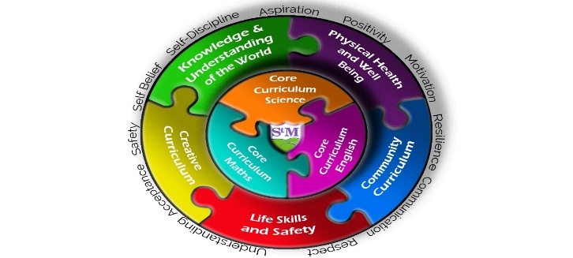 | Life Skills, Safety & Careers  IT - E- safety. Create programs that alter the size of shape. Program a robot to  draw letters of the alphabet and  pick up a beacon. Program a virtual  robot to follow markers on a map and retrieve an object. Code.org – hour of code challenge.  Covid safety in school and in the community.  Water safety.  Food and Nutrition- design superhero energy food – granola or flapjack.
Physical Health & Well-being  PE – Football – pupils will need football boots please.  PSHE - Going for goals!  Forest School | Community Curriculum  Local geography including fieldwork – the River Dee, the water cycle. Settlements, land use, towns and cities compared with rural areas. UK towns and cities, changes of land use in history. | Creative Curriculum  DT - Viking shields.  Music – ‘ You make you feel my love’ performing and appraising  Art - Vikings, printing techniques - including great artists. Create a Working Wall using Norse symbols.

