Is the technique or process of taking a rubbing from an uneven surface to form the basis of a work of art.
Max Ernst
Frottage (from French frotter, "to rub")

Was a German painter, sculptor, graphic artist, and poet. A prolific artist, Ernst was a primary pioneer of the Dada movement and Surrealism
Ernst used Frottage to produce pieces of art work
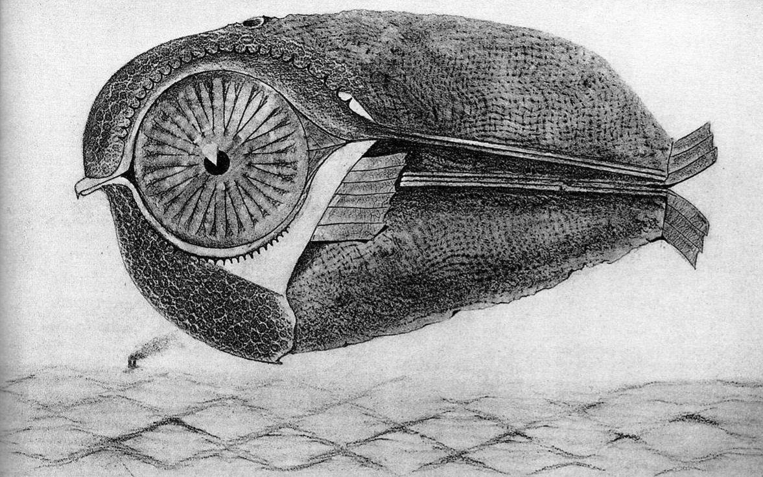

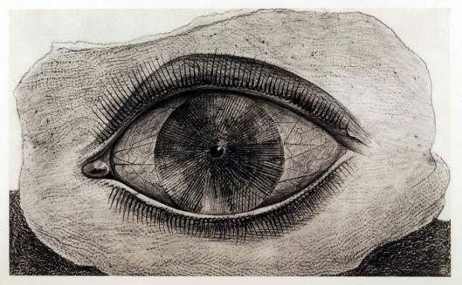
Frottage was developed by Ernst in 1925. Ernst was inspired by an ancient wooden floor where the grain of the planks had been accentuated by many years of scrubbing. The patterns of the graining suggested strange images to him. He captured these by laying sheets of paper on the floor and then rubbing over them with a soft pencil.
Technique :
In frottage the artist takes a pastel or pencil or other drawing tool and makes a rubbing over an uneven surface.
Task :
To produce your own piece of art work using frottage

